**NEAR EAST UNIVERSITY**

**Faculty of Engineering**

**Department of Electrical and Electronic Engineering**

**Generator Backup System for a Critical Load**

**EE 402 – Graduation Project Report**

**Students:**

**Khaled**

**Majd**

**Ameen**

**Abdo Elrahman**

**Asem Abdou (20193554)**

**Instructor:  Assist. Prof. Dr. Ali Serener**

**Nicosia -2021**

# ACKNOWLEDGEMENT

It is without a shadow of a doubt that my first and most significant expression of my appreciation is to God. It is only through the will of the Almighty that this research endeavor has taken place.

Contents

ACKNOWLEDGEMENT 2

Table Of Figures 4

List Of Tables 5

Abstract 6

1. Introduction 7

3.1 Aims and Goals 8

3.2 Difficulties 10

3.3 Contribution 11

3.4 TIMELINE 15

3.5 BUDGET 16

2. Literature Review and theories used 17

2.1 LITERATURE REVIEW 17

2.2 THEORIES USED 21

2.2.1 System Block Diagram 22

2.2.2 Three Phase SOURCE 23

2.2.3 Three Phase Transformer 25

2.2.4 Three Phase Breaker 27

2.2.5 Automatic Transfer Switch (ATS) 28

2.2.6 The Cooling System 29

3. System model and Work Done 31

3.1 System Model 31

3.1.1 System Model and analysing 32

# Table Of Figures

Figure ‎1.1 Backup Diesel Generator 13

Figure ‎1.2: Battery Backup Power 14

Figure ‎1.3: The Gantt Chart 15

Figure ‎2.1: Dynamo Generator 18

Figure ‎2.2: System Block Diagram 22

Figure ‎2.3: Three Phase Source 23

Figure ‎2.4:Three Phase Source Parameters 24

Figure ‎2.5: Transformer 25

Figure ‎2.6: Transformer Parameters 26

Figure ‎2.7: Circuit Breaker 27

Figure ‎2.8: Circuit Breaker Parameters 27

Figure ‎2.9: ATS Circuit 28

Figure ‎2.10: Cooling Subsystem Connected to Generators 29

Figure ‎3.1: System Model in Simulink 31

Figure ‎3.2: Control Panel 32

# List Of Tables

# Abstract

In unexpected cases, when there is a sudden failure in the power supplied to the facilities specially in the huge ones that require emergency backup systems by diesel standby generators, the installation of emergency backup systems (EBS) is as important as the oxygen we breath, like in hospitals that need to be 24 hours supplying electricity therefore oxygen to patients, electrical systems are being modified, built, and designed in order to ensure maintaining full power supplied to fundamental facilities. they are becoming necessary and critical, the importance of the backup generator followed up with the development of the interior system by performing design and simulation by MATLAB and SIMULINK softwares. Several studies have been done in the field of emergency systems, and this demonstrates its importance in our life. It is necessary to note that the issues of EBS are not new, although all the main issues were considered within this research to make sure we are optimizing the emergency systems on all parameters variations and achieve the most efficiency on such systems, even though, multiple problems was faced during the implementation, but we figured out flexible solutions for these difficult issues, by following certain procedures beginning from the design of the blocks and ending with selecting the appropriate parameters to maintain the best stability and highest possible efficiency throughout the entire system. In our system we managed to simulate a complete emergency system for a critical load by having three diesel backup generators and the main electricity source, the flexibility to switch between them at any point through the simulation process. Basically, one of the characteristics of system reliability has been the power security of the EBS, which states the ability of the system to endure unexpected disturbances without accidental effects on electricity consumers. Simultaneously, the examination of power security was mainly performed on a simulation perspective and programmatical logic. Deeply speaking working this type of projects needed a high accuracy and assuring the perfectly fitting blocks.

# Introduction

Backup Generators are one of the most important inventions in electricity and this is clear from its contribution because it compensates the sudden outage of the electricity especially in important facilities that needs electricity for 24 hours. When the electricity goes out and the facility becomes all down, with nothing working, this would have severe consequences, and you cannot do anything until the assigned service company finds the problem then try to fix the issue and by then the facility will work again, and here comes the importance of Backup power systems.

In electricity generation, the mechanical power is converted to electrical power and through this process, there are many circuits and connections that assure a perfect and successful electricity generation, but there is a critical and essential factor in this process which is safety circuits that guarantee human’s safety and reduce machines loss based on cost, effort and so on, yes electricity is a great invention that changed the whole world in a very great way, it’s a revolutionary invention, on the other hand, we need to be very cautious while dealing with it whether we are just consumers, technicians, or engineers. Hence to reduce risks as much as possible there will come the purpose of this proposal power, safety circuits and connections.

Here we will talk about an integrated system that works when there is a power outage together with the emergency backup system to make sure the power is always supplied to the facility, so this system depends on generating electricity by diesel generators, and the reason diesel generators are chosen is because diesel generators are more efficient in terms of fuel, using only one-third of the amount of fuel as other types, this fuel-efficiency adds up to significant savings over time, longer operating life and lower operating cost compared to other generators, and this system is highly reliable as well as high efficiency.

Our job in this project is to simulate this system on MATLAB and SIMULINK softwares and estimate the most real situations and guarantee the most accurate execution in the real life, going from the absolute beginning of studying the whole system and analyzing every and each part precisely in order to have a clear vision of what we want to achieve at the end, working in such system was very highly structured and organized, we took it step by step, block by block till we move to a new phase after ensuring we achieved the best result in that particular phase.

## Aims and Goals

The main goal in this project is to design and simulate a generator backup system for a critical load with selecting certain parameters for the applied sources and following a particular implementation for the whole system. At the same time, we have combined and make corresponding of the generators and the critical load powers in order to make a match for the measurements of the other blocks to be synchronized. We also made sure to provide the blocks that ensure the full safety for the circuits in order to be compatible with any failure the system could have; also, we provided a certain sequence for the generators to have a cooling period. Last thing was designing the control panel application for having the opportunity to control the simulation process through it.

The complementary goal for this project was gaining the experience of team work; it was new trial for most of the team members but it was necessary for engineers to know all the different aspects related to co-operative work and gave us wide knowledge to share between us.

We had the opportunity to make the simulation test multiple times and that generally led us to know and learn more about the specification of every block we used in the program by following the modification procedure throughout the whole system and especially matching the parameters that were not given in the description.

The goal was reached by dividing this work among us, we consist of six members in the group and each of us worked on his own task as follows:

* First task: The design and simulation of Diesel engine powered generators.
* Second task: The design and simulation of load balancing and synchronization of generators.
* Third task: The design and simulation of all the power and safety circuits and connections.
* Fourth task: The design and simulation of generators and mains failure and become operational events during the course of system simulation.
* Fifth task: The design and simulation of remote monitoring and control of generators via internet link.
* Sixth task: The design and simulation of intermittent operation of generators. Such as, each generator shall go to a cool-off period in turns after 8 hours of operation. Once a generator comes off from its cool-off period one of the other generators shall go to a cool-off period.

## Difficulties

Difficulties are considered challenges to accomplish any task, so we must challenge the circumstances and difficulties where the graduation project is one of the most important stages that any student goes through in the university and therefore there must be some challenges and difficulties at this stage of university life therefore it required us to face such difficulties and to find solutions, such difficulties that we faced as a group doing this task and how to complete the project to avoid any difficulties and there are many difficulties faced by the student and set a plan to face such difficulties I want to talk here about some of these difficulties:

In the period of **COVID-19** we faced many difficulties individually and in terms of the team too, in the following points I will show the difficulties that have been faced during the timeline of the project.

* Research: In our university life we learned to work as a team when we face any difficulty for this although we do not have full knowledge in the management of the graduation project and how to work continuous research in many books and references that concern our project about the electrical monopoly system and the work of the simulation system for this project and works without any problems at work.
* Meetings: Also, of these difficulties, which are the most important ones, which is meeting and working as a group and was exceedingly difficult in the presence of the virus Corona spread in the world that we were stopped from meeting with each other and traveling to Turkish Cyprus to meet and accomplish tasks and we had to meet via the internet on one of the applications and complete the project with high accuracy.
* Program selection: Difficulty chose the program as the lack of knowledge in the programs that specialize in the work of simulation where it was one of the difficulties and require us as a team to overcome this difficulty and work a lot of research to choose a program that does this job.

## Contribution

Let us start directly by giving a brief explanation of the definition Backup power generating system and its importance in our daily lives, one of the main purposes of that system is to improve the reliability of the power used. That system is restoring so quickly and maintaining the parts of the facilities, campus, territories powered up for minutes, hours, or even days. If the utility power has failed to do its main function for a few seconds, the backup system is operated to reduce the costs of the utility power in some particular cases, the interruptions of the electricity can happen anywhere, anytime and can last for seconds or even hours without a previous warning. This is dreadful thing for food companies, government institutions, hospitals. Because in food companies an entire supply can be thrown out for manufacturing factories, in hospitals we are talking about life and death, for the working companies round the clock the power is so critical and decisive factor. many commercial and public companies are always purchasing the backup power units in order to avoid the losing in time and also losing the contact with customers due to electrical disruptions, if the employees can get back to work as soon as possible and go on with operations, the minimum the hit will be to the bottom line during the power outage. The backup power system also can protect business facilities from theft, and I will explain why, if a power failure happened and extended for a long time, your premises might be exposed to looting and break-ins. The backup system helps and enables you to protect your business from potential intrusions by the feedback of restoring security system and lighting instantaneously. It also can protect your business from weather, as we all know the extreme weather can cause disruptions as well as humidity, freezing and high temperature conditions. It also protects you from hacking, these days the threats from hacking of cybersecurity due to terrorism are so rapidly increasing, so the backup system can ensure you can fight back these threats in case of power fail, also one of its most important advantages is the ability to hedge, to able to transfer a backup power system unlock your business to the option of alternative energy plans that can save you money, let’s take an example, you can find a demand response program that helps you lower the bills as the same as generating income by paying you to minimize or shift the usage of electricity during the peak time. The backup power system can be in different sizes and shapes, with the most popular being natural gas fired or diesel generator that has been installed on site, the facilities of cleaner energy such as biogas, solar panels or wind turbines can also constitute or compose part of the backup energy solution. but the most common thing between all of them is the ability to supply business resilience by ensuring the access of the electricity all the time. One of the most important sectors that desperately needs that kind of a system is the education sector. Colleges, schools, higher learning institutions, all of them have huge educational systems powered by electricity and unfortunately if power failure happens that can lead to great inconveniences, most of the systems include phone networks, lighting, research equipment, fire alarms, ventilation, elevators, data storage, computer networks, cooling and heating. All of them play an integral part to guarantee the comfort and relief of the students as well as the functionality of the educational system, without that important system the school may be obliged to shut down some time of the day due to interruption in the planned studies. That can put the safety of the students in danger and require the school to negotiate with the parents to pick the children early out of the school which can be a real nightmare because of emergency and safety and most of those parents will not be available due to their jobs, for the higher learning institutions the power failure could result in money and time losses for the faculty and students. Most of the important and integral data could be vanish and there will be damages with the vital equipment, it will also be impossible to proceed experiments of time based and power during the outage or even after the restoration of the power.

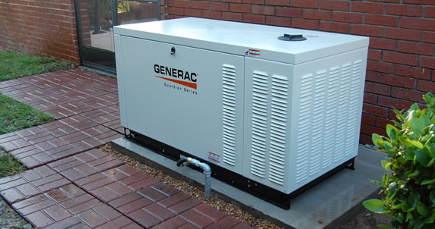

Figure ‎1.1 Backup Diesel Generator

As we previously mentioned in case of power failure from the utility, buildings depend on the backup power system for both safety and the public health as well as the protection of business facilities which will be an awful disaster if it is suddenly lost due to a power outage. Unexpected crisis usually disrupts the power to hundreds of thousands of businesses and people. Many facilities such as airports, hospitals, data centers, gas stations, water and sewage facilities, transportation and communication systems need some kind of alternative power to eventually save lives during the case of disasters. The power disrupt to a business facility can cause a significant economic impact, the longer the business in the most need of power, the greater the economic losses, when these unexpected disasters occur, the backup power system provides a source in order to support the equipment loads through uninterruptible power supplies, generators or even battery storage system.

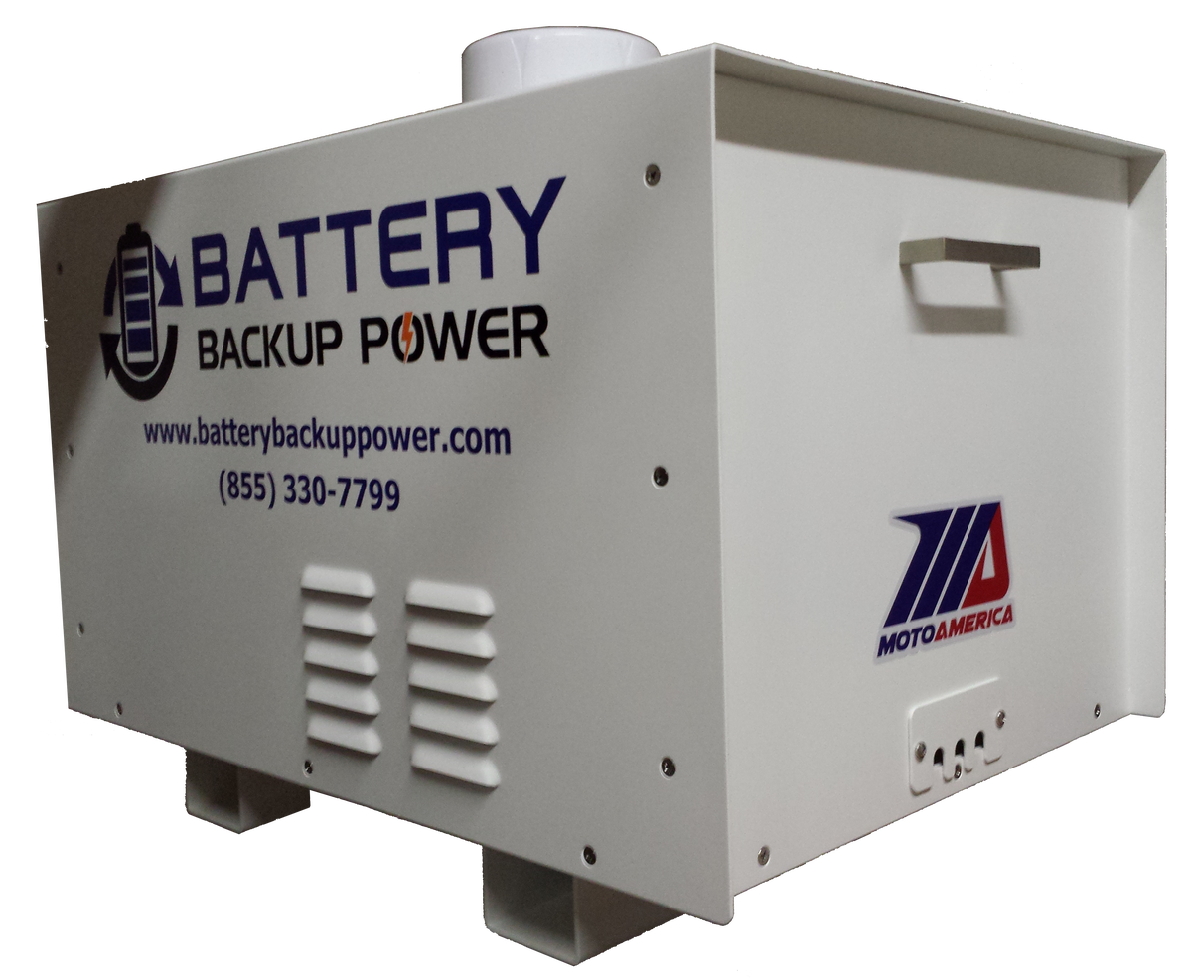

Figure ‎1.2: Battery Backup Power

## TIMELINE

Figure ‎1.3: The Gantt Chart

This figure (1.3) shows the timeline of the project from 6th April when building the team till presenting the project at January 2021 and it shows the duration of each task based on the estimated length of its rectangular bars. the project will be prepared during 2020 summer like working on the design and simulation till writing the report then presenting the project at January 2021.

## BUDGET

The table below shows the budget for the whole project. The table clearly states the name of the software we used and a brief description of the specific type of the item.

Table 1.1: Table for Budget

|  |  |  |  |  |
| --- | --- | --- | --- | --- |
| No | Item | Type | Description | Total cost |
| 1 | Computer Software | MATLAB and SIMULINK | Design, simulation, and programming | 55.5$ |

The Table 1.1 above explains the softwares we need to complete our simulation with the type and description of the item that we need to work on, as well as the price of one item and the total price given in the US Dollar.

As you can see, we are going to need only a computer program for this task in order to make the simulation closer to reality as possible.

# Literature Review and theories used

In this section we will be talking about the history of Backup Generators, when it has been used the first time, how it was working, then we will advance with the topic through the evolution of the electricity and its effects on the evolution of Backup Generators.

We are going to provide the process that we went throughout this project and we are going to talk about the simulation procedure that was done in addition to all the steps of the design and combining the components in a practical way, also we will be giving the full explanation of the cases that could happen according to our tasks.

We chose MATLAB Simulink program to make our work done due to its ability of making the imagination closer to reality. You will also find the theoretical principles and foundations of how the system of Backup Generator systems work in a simulation perspective.

## LITERATURE REVIEW

Developers and engineers have proven that the electrical backup generators to be one of the most fundamental devices that most of the people use among different facilities, the dependency on device that can generate electrical power instead of the main electricity source can ensure safety, saving lives, and saving companies from collapsing. Even though, we see that most of the backup generators are founded in important facilities only, but developers expects to have generators among other vital facilities in order to ensure the full security around several business and establishments. Talking about the importance of the electrical, medical facilities are one of the most essential complexes that need power supply to be generated continuously, so what if the main source suddenly failed to supply the needed power? It could lead to various losses. So we can say that critical establishments such as industries, companies, and private complexes in general need a backup system to generate the electricity among them.

The first stage of the invention goes back to 19th century, the first discovery was the electromagnetic induction event which the same of that what we call today “Faraday’s Law” which is basically a generation of an electromotive force inside an electrical conductor.

The first development came in 1932 by building the first dynamo generator.

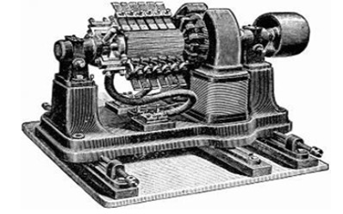

Figure ‎2.1: Dynamo Generator

The figure 2.1 is the first design of a dynamo generator; this development was invented to deliver power by the pulses of electricity and without a current passing through.

The invention of the generators is already considered as main purpose for humanity at the 19th century, but also the development of these devices is important, as the development grows, it became easier for usage and more safety is ensured to try as much as possible to cover all the possible situations damages that could happen.

The first electrical generator was the dynamo generator, this model was invented without current but with pulses of electricity and it was first electrical generator to deliver power for industries. After that, the development was focused on the elimination of the alternative current to reach the direct current power.

The next developments of the dynamo generator focused on providing continuous DC power and creating self-powered electromagnet rather than the weak permanent magnet, and this development was successful in different aspects either from its power or usage in general, this operation remained until it went to the discovery of the AC systems. [1]

Until now, after many researches and studies, we reached into the generators that make an implementation by substituting the power supply into the electricity by running water turbine; this process provided larger energy that it is more than enough. These generators are usually different in size, they are usually larger. At the same time, the well-known generators that are founded in the commercial and residential facilities, these types’ works by fuel sources such as diesel, propane, and gas. [3]

Generators that depend their sources from fuel were the latest development reached in the past years, and diesel generators left a great impact mostly among their other competitors due to their ability to supply power to the load directly and also the ability of storing the generated power in their batteries. They are mostly used and founded in modern industries. [3]

The greatest development reached for generators is highly contributed with technology and especially the smart devices, now we have the ability to control the generators from mobile applications and from internet links as well.

As we know, the main purpose of the generators is to supply power in case the main power supply failed for any reason, but there also other reason of the generators in other aspects, some work totally depends on them in different ways, so here are some examples of the generator usage:

Backup power for business facilities: The best way to ensure uninterrupted power supply in the medical facilities is to put extra resources that can supply the same process. Hospitals are required and responsible to maintain the full power all over the departments for the patients in order to ensure the safety of their patients. [4]

Construction areas: The construction working points require many different electrical devices to be working such as: machines, trailers, ventilation, saws, grinders, drills, and other tools, and usually construction areas contain main power source but it often cutes between a time and another unexpectedly, so it is necessary to have a backup power supply in such cases. [4]

Agriculture and ranching facilities: The usage of the generators in agriculture facility is sometimes considered as primary sources to supply electricity for water pumps. The irrigation systems usually work from the generators power supply. [4]

Mines: mines facility also uses the generators widely to get their work done; the estimation of the mining operation from generators is about 70%, their need for it usually concentrated in shovels, excavators, and lightning up the deep tunnels for the workers. [4]

The usage of the backup systems is not confined around working facilities, but also generators are used a lot around other activities such as: weddings, fairs, sporting events, and camping. [4]

The future of generators and their systems in general is very wide due to its improvements, efficiency, and simplicity of work; developers expect to have generators capable to be friendly with the environment and reduction of its loud noise as well as the discharge of the chemical gases, and the future generators is associated with the requirements of the people needs especially in critical facilities. In financial aspect, diesel generators sales are expected to be growing up to 21 billion dollars in 2022 which means a huge range from the market in 2014 which was 12.6 billion dollars. Energy information administration is expecting that the developing countries will represent 65% of power usage in 2040. The contribution of the simulation with generators in the future is also high, because the expectation for this process method is associated with the climate scenarios. [8]

## THEORIES USED

In this section we will talk about the parts of the project in design and simulation perspective, the circuit, or the Blocks that we used in the simulation and the connections that made the project.

The connection, the blocks will be demonstrated in detail as also their parameters.

This will be divided into the following parts:

* A block Diagram for the basic structure of the backup system.
* Sections of the system
* The main source of electricity which is called the grid.
* The safety circuit components used in diesel Backup generators and the whole system.
* Connections of Components or blocks.
* Table of Cases for the operation cycle between the backup generators and the grid

### System Block Diagram

In this part we are demonstrating a full block diagram of the system and to make it as much simple as possible to understand how does the system work. The system is divided into several sections, the grid section, the backup generators, the load, the measurements section as indicators to each main part, the cooling system, and the automatic transfer switch.

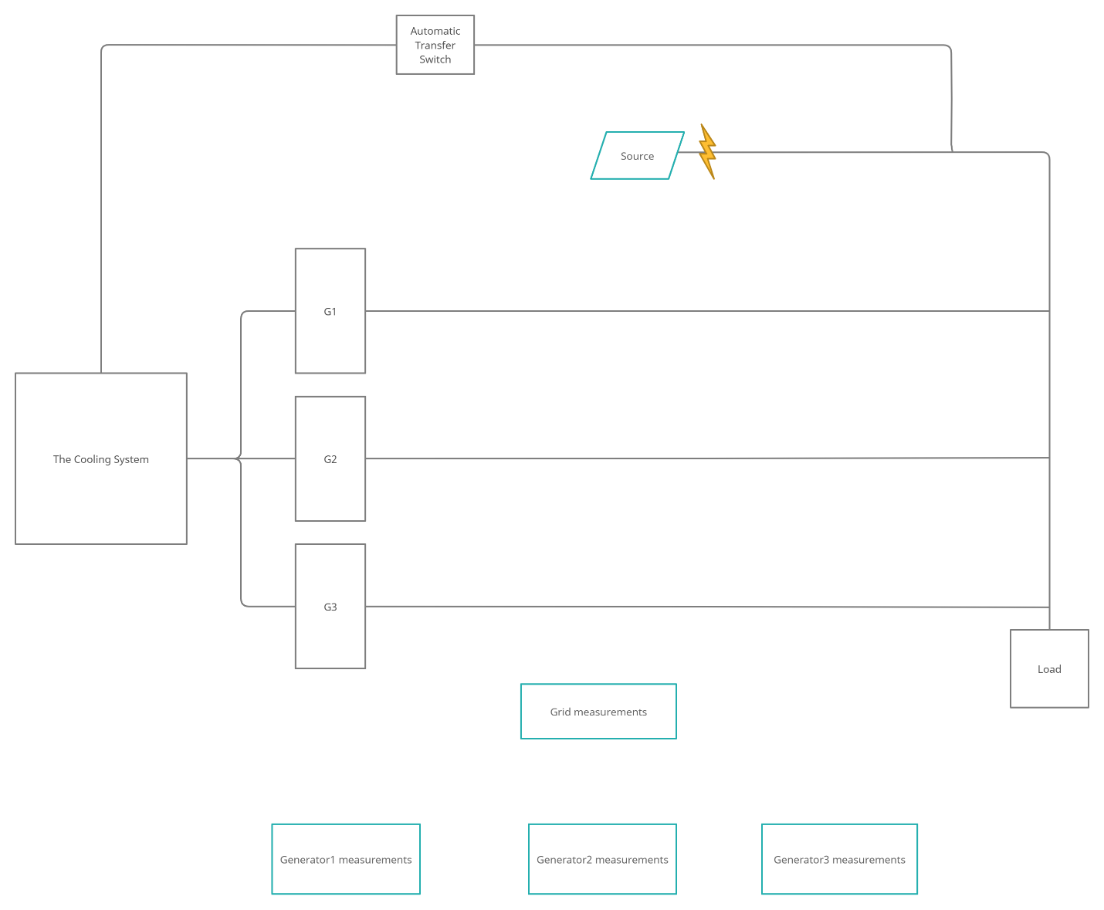

Figure ‎2.2: System Block Diagram

### Three-Phase SOURCE

The main source section in our system was designed in Simulink by 3 blocks, which are the

* Three Phase Source
* Three Phase Transformer
* Three Phase Breaker

**Three Phase Source**

The main role of the three-phase source block is distributing three-phase voltage along with R-L impedance internally. This block is usually connected as wye-connection (Y) and can be available when it is either connected to the ground or to a neutral connection. There are two ways to make a specification of the internal source and they are named as direct and indirect specification, either by putting the values of R and L or by and this is the direct way, or by appointing to short-circuit level induction and the X/R ratio and this is the indirect way.

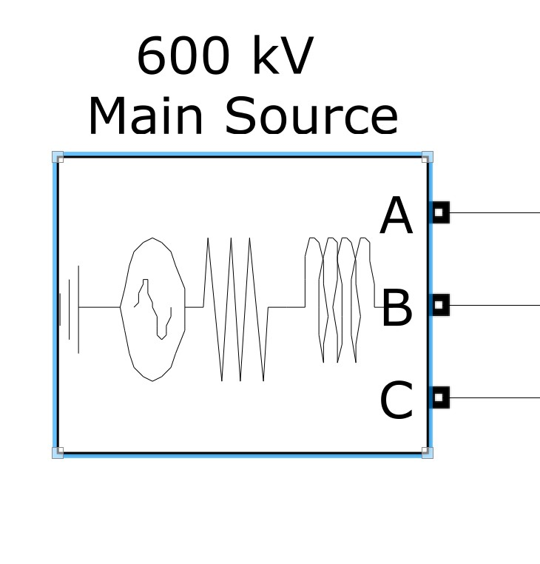

Figure ‎2.3: Three Phase Source

**Block Parameters**

The parameters values specifically should be selected carefully in order to ensure the result of the desired system, as the connection internally is wye-connection (Y) alongside the ground which symbolized as Yg in the system.

All the values are already set in figure 2.3 above, the voltage is 13800 V phase-to-phases, the angle is 0.071468°, and the frequency is 60 Hz.

The induction of the three-phase short-circuit power is given with SI unit of volt-amperes (VA); it indicates the internal inductance L. The default value is 100 KVA. The availability of the parameter is contributed with the selection of the internal short-circuit level parameters.

The calculation of the internal inductance L is founded by the equation given below, its value is in Henry (H), and the value is calculated from the power of the induction of three-phase short circuit (Psc) with VA as SI unit, Vbase and it is phase-to-phase voltage with volt rms value, and the frequency in (Hz).

Equation ‎2‑1

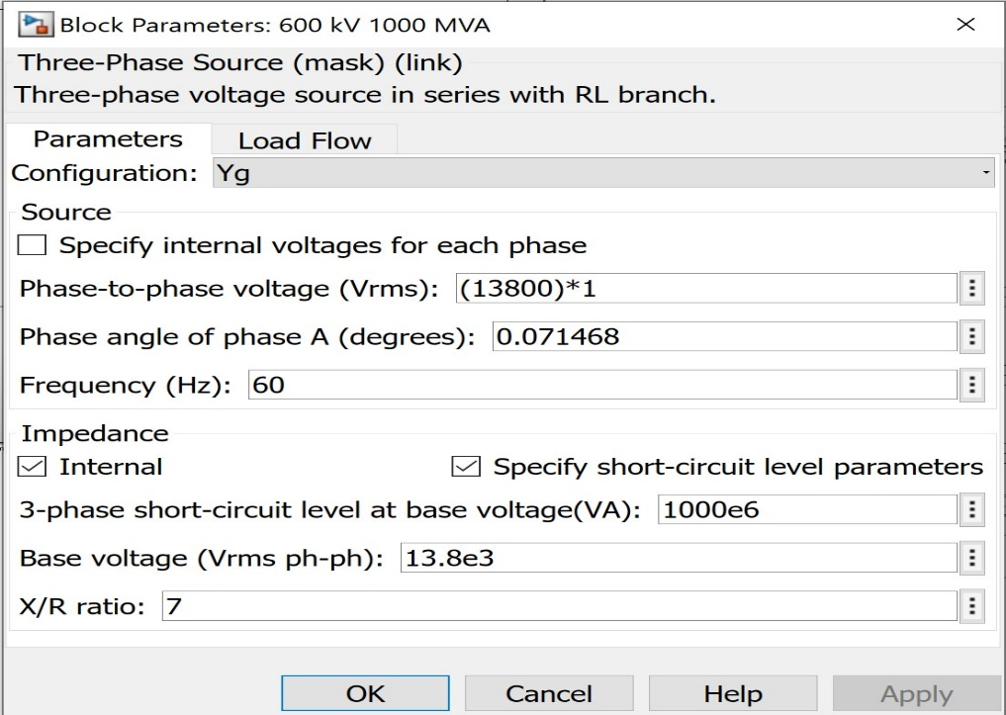

Figure ‎2.4:Three Phase Source Parameters

### Three-Phase Transformer

This block implements a three-phase transformer using three single-phase transformers.

When activated, the saturation characteristic is the same as the one described for the Saturable Transformer block. If the fluxes are not specified, the initial values are automatically adjusted so that the simulation starts in steady state.

The leakage inductance and resistance of each winding are given in (pu) based on the transformer nominal power Pn and on the nominal voltage of the winding (V1 or V2). For a description of per units, refer to the Linear Transformer and to the Saturable Transformer.

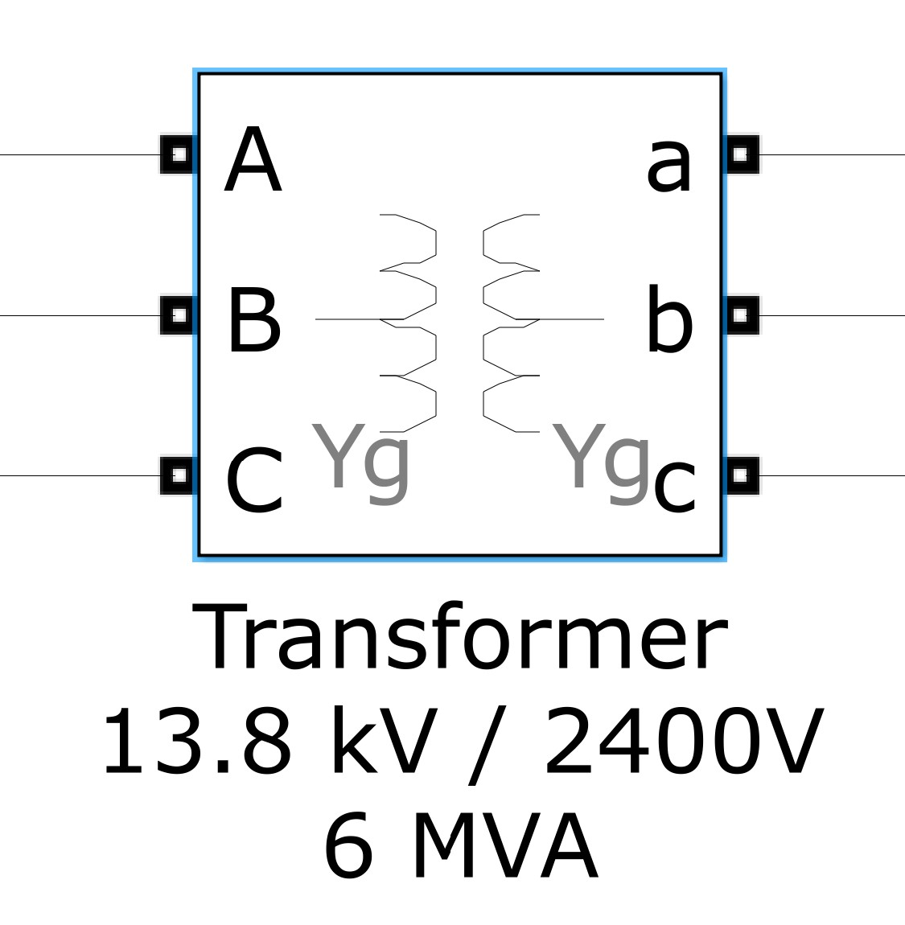

Figure ‎2.5: Transformer

**Block Parameters**

The primary Connections are connected in Y connection to the ground as indicated by Yg

As well as the secondary connection. The core type in the transformer is three single-phase transformers.

The nominal Power Pn is set to 5 MVA, and the frequency is set to 60 Hz.

The Primary windings parameters are set to 13.8 KV as Ph-Ph and R1 is set to 0.0015, and R2 is set to 0.03.

The Secondary windings parameters are set to 2.4 KV as Ph-Ph and R1 is set to 0.0015, and R2 is set to 0.03.

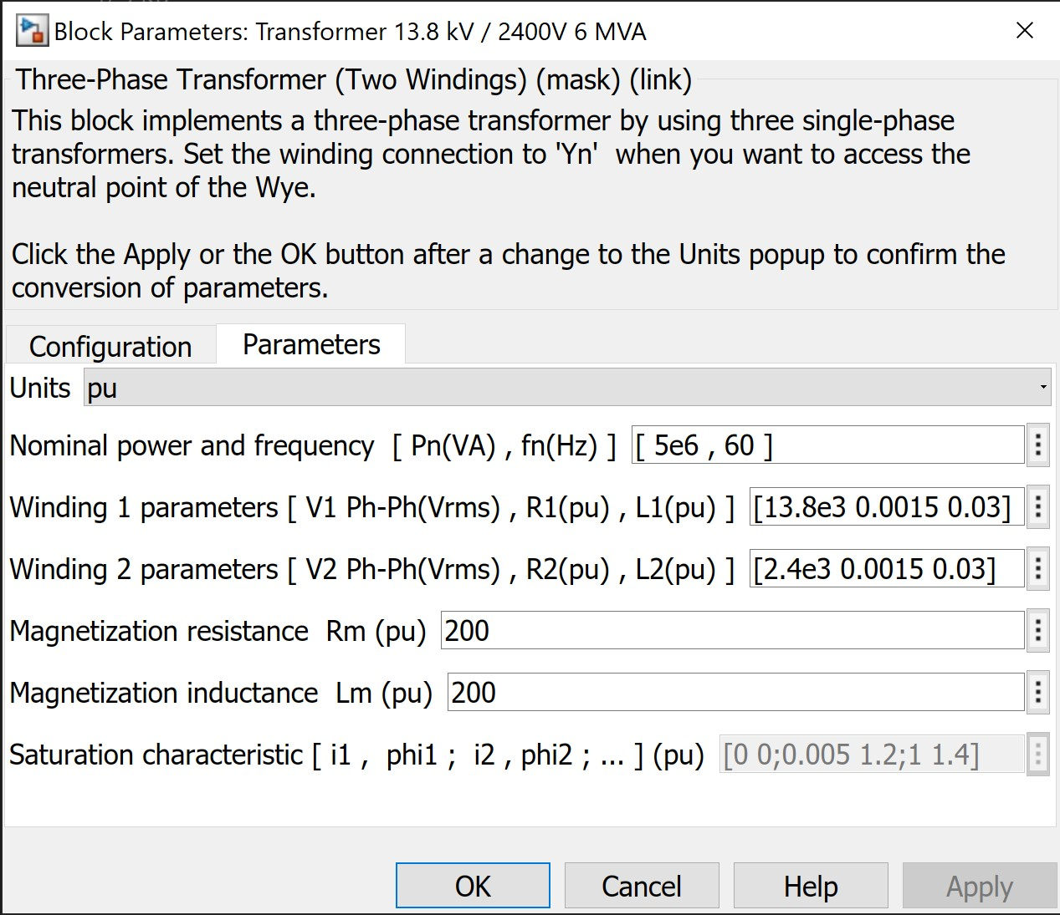

Figure ‎2.6: Transformer Parameters

### Three-Phase Breaker

The circuit breaker is in the main source section is one of the most important components in our system, it is the key part of switching of and on the grid when there is any failure in the system.

We represented the failure in the system by a controlled constant with values zero and one.

The circuit breaker is essential in the safety of our system, it is common activated type, in other words when the circuit breaker receives zero it opens the circuit and there is no current flowing to the load, at the same time there is opposite signal flowing the backup system to ignite it to work.

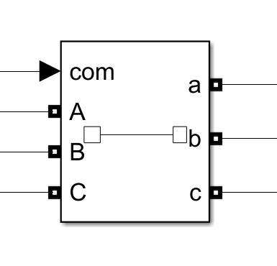

Figure ‎2.7: Circuit Breaker

**Block Parameters**

The initial status of the circuit breaker is set to closed as we want it to open when it receives a signal with value zero, breaker resistance is set to 0.01 ohm.

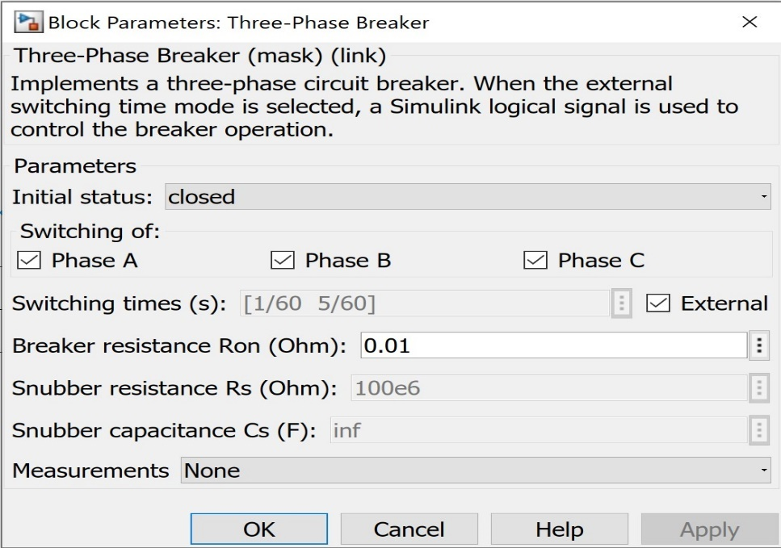

Figure ‎2.8: Circuit Breaker Parameters

### Automatic Transfer Switch (ATS)

This is switch is one of the key-element in any emergency system because its benefit of self-acting depending on whether there is a failure in the system or not, so if the grid fails for any reason it activates the common input in the circuit breaker therefor the breaker breaks the circuit, and the backup generators get to work.

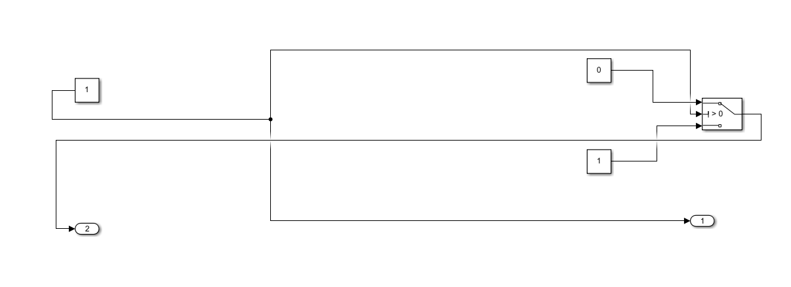

Figure ‎2.9: ATS Circuit

The functionality of the ATS shown in the figure above is as following, the port number one and two are output ports.

The constant about the output port 2 is what controls the ATS function as this constant is switchable through a Rocker Switch and by this way, we are simulating the failure of the system, by switching it off or on at any moment we want.

So that controlled Constant if its value is 1 it compares with the controlling input in the switch.

If 1 > 0 the first input in the top will flow to the output port number 2, if 0 > 0 which is not correct then the last input at the bottom will flow to the output port number 2.

If the output port number 2 has the value 1 then that means the output port number 1 has the value zero, hence the main source will be off since it is depending on the output port number 1 because it is connected to the circuit breaker.

Therefor the backup generators will operate because it is receiving the value one.

### The Cooling System

The cooling system is what guarantees the most efficiency to the entire system through alternative operations to the generators.

In this section we will talk more theoretically about the cooling system, later on the work done chapter we will talk more practically about it.

The cooling subsystem connected to the three generators to control their operation time.

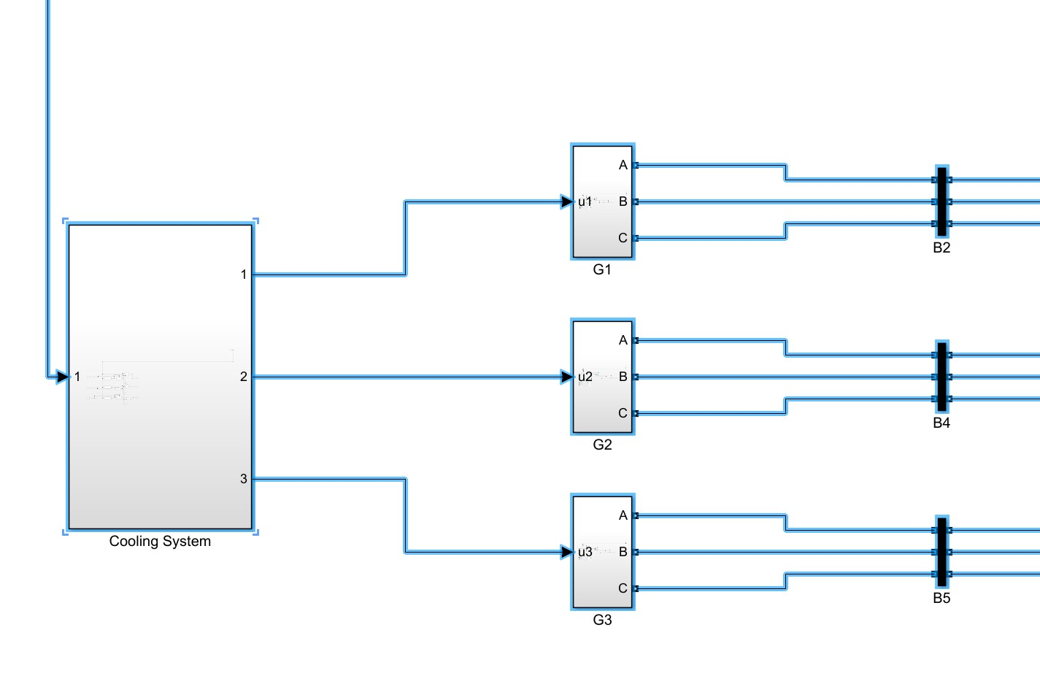

Figure ‎2.10: Cooling Subsystem Connected to Generators

The components used in the cooling subsystem are listed in the next lines.

1. Three Repeating Sequence Blocks.
2. Three if blocks.
3. Three if action subsystems.
4. Three Switches
5. Three constants with value zero

**Repeating Sequence Blocks**

These blocks outputs periodic sequences based on the values being set in vector of time values parameter and vector of output values.

**IF Blocks**

The if blocks are ensuring the ATS function throughout the cooling system if the input is set to 1 then the if function will make the sequence block flows to the generators.

**IF action subsystem**

Each (if block) must be connected to if action subsystem to apply the logic.

**The switches and their constants**

Are to make sure if one and only one is coming from the ATS then the generators shall work if any other value than one is coming the value zero of the constant will be directed to the generators.

# System model and Work Done

In this section we will talk about everything we did in the project from a practical view.

First, we will show the model of the system in Simulink in order to conceptualize and construct the system, by having the modelling for the system it’s easier to analyze and understand how the system works.

## System Model

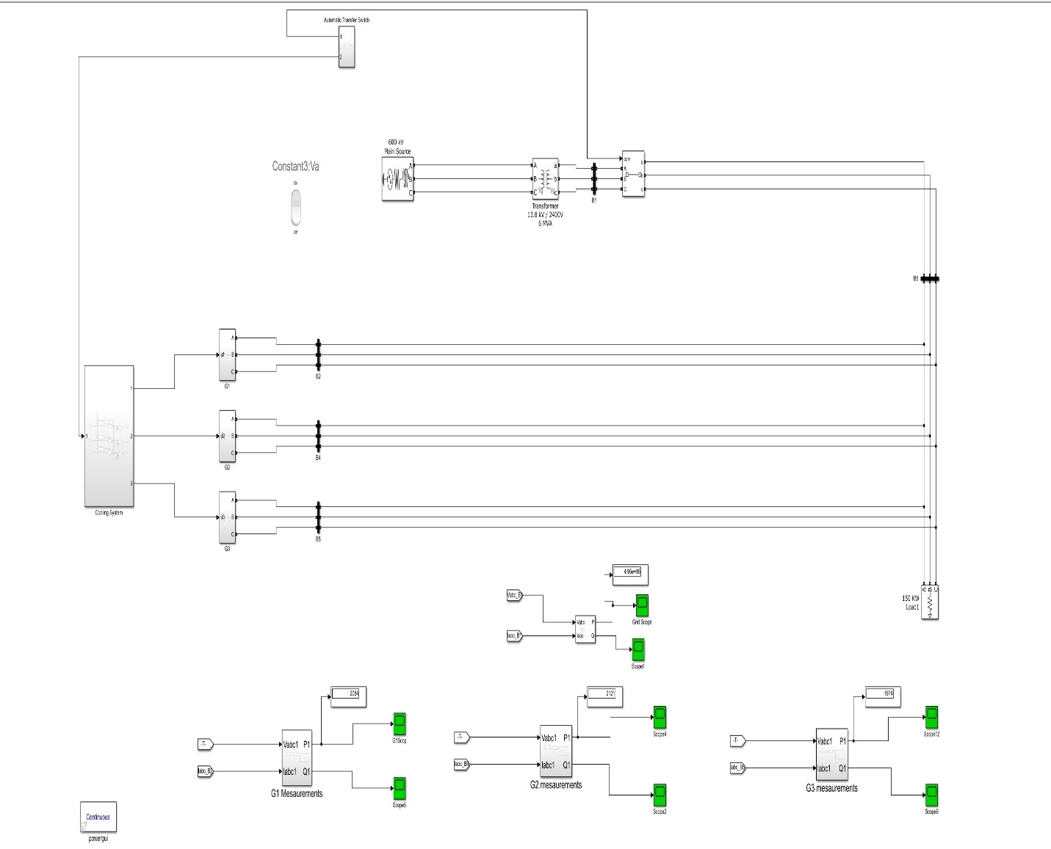

Figure ‎3.1: System Model in Simulink

### System Model and analysing

Having a well-structured system was our main goal from day one in working in the project. We managed to structure the project into subsystems, each subsystem contains its circuit and blocks that leads to a particular function or result, as example the subsystems we have in the project are:

1. Automatic transfer switch
2. Cooling system
3. Generators
4. Measurements of each generator
5. Control Panel in MATLAB Application Designer

In figure 3.1 above it shows the design of the system with all subsystems and connections between them.

Everything is controlled through the control panel shown in (figure 3.2) below

Figure ‎3.2: Control Panel

## work done

The work done part will be divided into 2 parts:

1. The design of the system
2. The simulation and its result

### System Design

The design of the system was incredibly challenging at the beginning, looking for the right components to use, where to use them, and where to connect them and what would be their parameters.

First, we started by breaking the whole projects into small milestones, so we understand clearly what we need to do till we achieve that milestone.

We started by the main source of the system what it would be and what component to use to achieve the idea of main source (Grid), as well as the backup generators.

How we are going to represent a backup diesel generator, and the ATS, the cooling system, the load of 500 KW, and the control panel or even the remote control to control the system via the internet link.

Listing all the needs is a step of finding the solution process. Finding what you don’t have makes you know what you need to have in the end in order to make something works for you.

In the next pages we are going to list the components and the parts of the system to show them in action.

**Design Criteria**

* Three Synchronous Diesel-powered generators with 600 kW power generation
* Critical Load with 500 KW
* Primary Source (Mains)
* In case the mains have failed, the generators shall supply, the power to the load and distribute the load equally among themselves.
* In case one or more of the generators fails/become operational again.
* the working generators shall redo the load balancing.
* When the mains power becomes available, the generators shall stop.
* All the generators should operate synchronously.

First let us start with the **main source**.

**Three Phase Source**

**To have a Three-Phase Source** which is necessary to implement the main source of electricity in any system. And that was a key block in our system design criteria, in the next lines we are going to talk about three-phase source block as we used it exactly in the design.

Is the main power source in any building or facility, and we represented it by using the block in the figure below

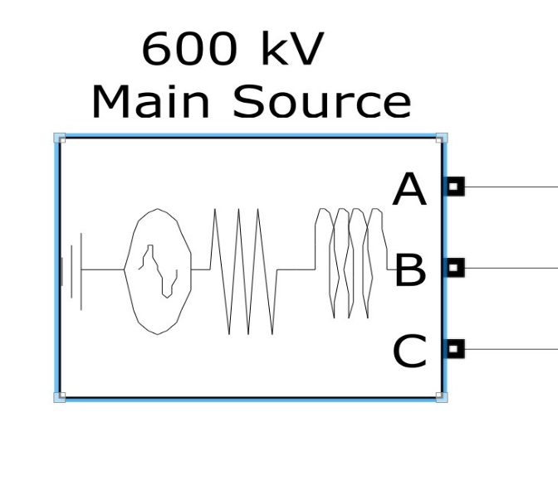

Figure ‎3.3: Three Phase Source Block

**The Diesel Generator**

In our system we designed three diesel generators based on our design criteria, in the next lines we are going to show the generator components in the design.

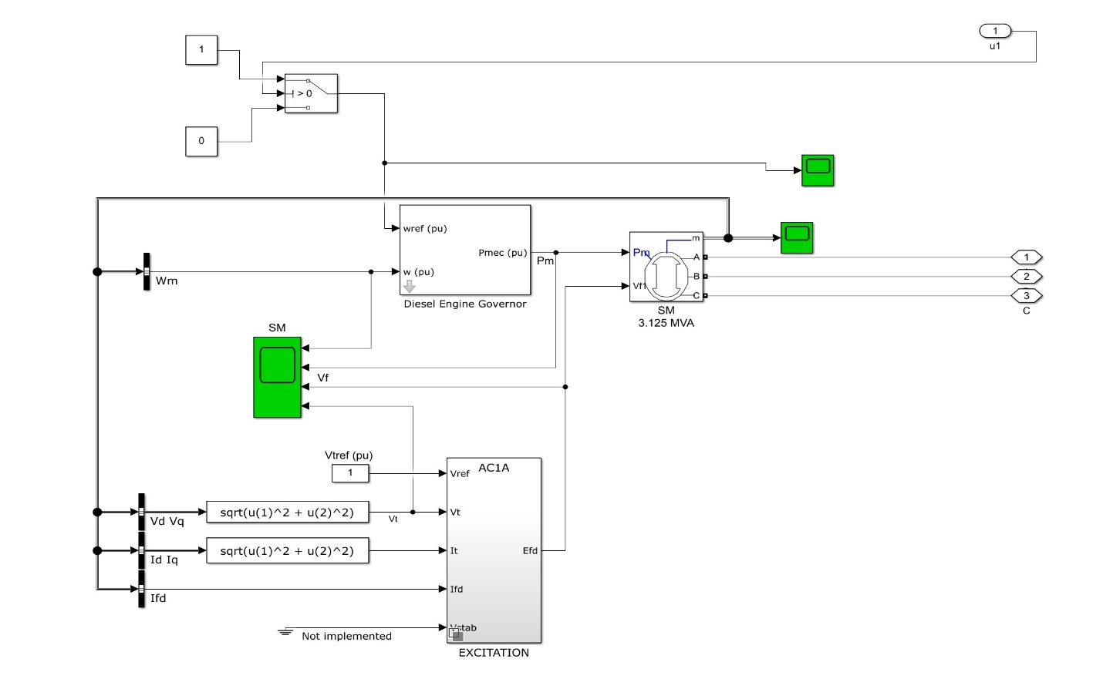

Figure ‎3.10: Diesel Generator Unit

The Work of this diesel generator unit is to produce 600 KW active power, for more obvious information listing we will show the blocks parameters and configurations.

The diesel generator is consisting of

1. Diesel Engine Governor
2. Synchronous Machine
3. Excitation System

**Diesel Engine Governor**

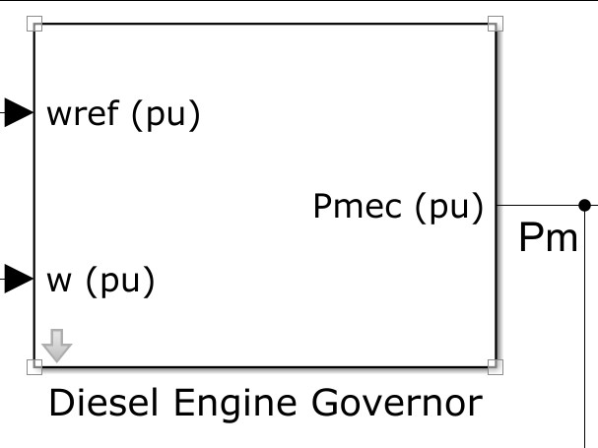

Figure ‎3.11: Diesel Engine Governor

Figure ‎3.12: Diesel Engine Governor Parameters

### System Simulation

Simulation of a any system is the operation of a emulating in terms of time to graphically showing changes according to some design criteria and based on the factors selected in the design criteria the system should be designed, which helps analyze the performance of an current or a proposed system. In different words, simulation is the technique of the usage of a mannequin to find out about the overall performance of a system. It is an act of using a model for simulation.